
A 10
Sreenidhi Institute of Science & Technology
(An Autonomous Institution)
Code No: 101EE43/111EE43

B. TECH. I – Year II – Semester Examinations, June/July, 2012 (Regular)
NETWORK ANALYSIS ( ECE & ECM )

Time: 3 Hours Max. Marks : 70

Note : No additional answer sheets will be provided.

Part-A (Objective Type)
Max.Marks:20

Answer all QUESTIONS.

1. A Voltage v(t) is applied across two inductances L₁ and L₂ in series. Determine the equivalent inductance L_{e} which can replace them and yield the same circuit.
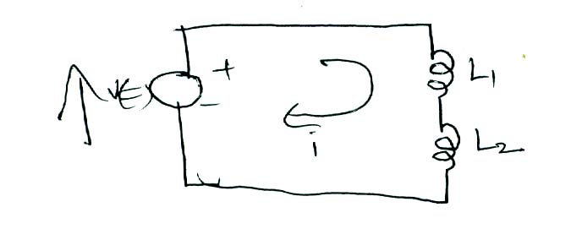
2. Find the average and effective values for the function y(t) = y_{m}sinωt
3. Two pure circuit elements in a series connection have following current and applied voltage v=150 sin( 500t+10⁰ ) volts, i=13.42sin (500t-53.4⁰) amps. Find the elements comprising the circuit.
4. Differentiate between active & passive elements.
5. Find the L_{eq} for the circuit shown in fig.
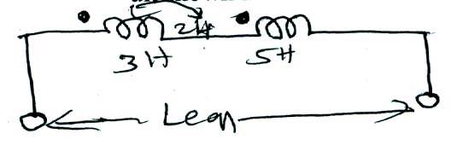
6. Define the following
a) Tree b) Cotree
7. State the maximum power transfer theorem.
8. Draw the h-parameter model of the two port network.
9. Explain Low pass & High pass filters.
10. Obtain S-domain equivalent for the following elements a) Resistor b) Inductor with initial current I₀.
Part – B
Max. Marks: 50
ANSWER ANY FIVE QUESTIONS. EACH QUESTION CARRIES 10 MARKS.
1. a) Find the voltage to be applied across AB in order to drive a current of 5A, into the circuit by using star-delta transformation?
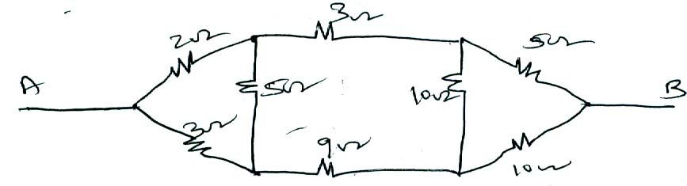
b) State and explain KCL and KVL and distinguish between
i) Independent and dependent sources
ii) Ideal and Practical sources.
2. a) Two identical coils connected in series gave an inductance of 800mH and when one of the coil is reversed gave an inductance of 400mH. Determine self inductance, mutual inductance and the coefficient of coupling.
b) A series RLC circuit has R=10Ω, L = 0.01H and c=100 µF find
i) Resonant frequency ii) Q factor iii) Bandwidth.
3. a) Find the form factor for the following waveform.
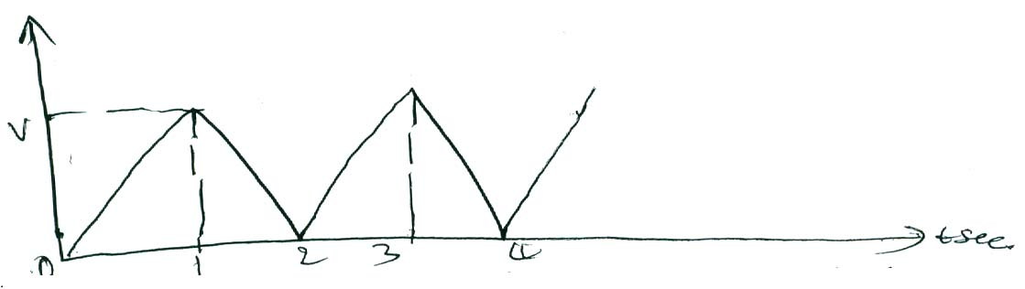
b) Determine the potential difference between the nodes P & Q.
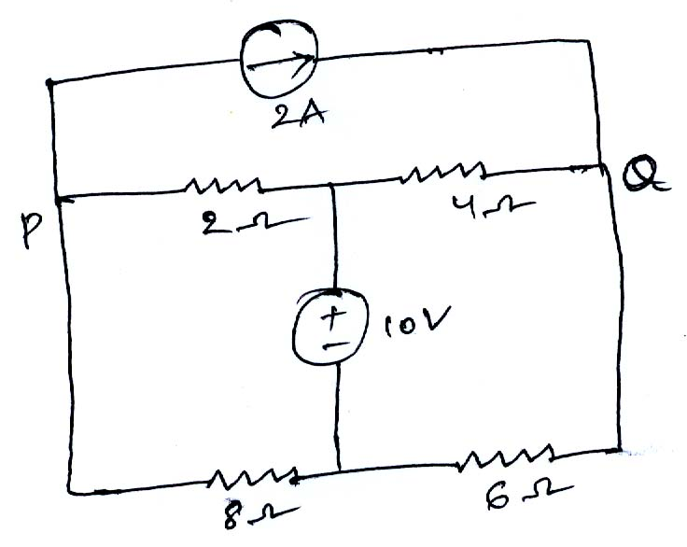
4. a) Draw the dual network of the following circuit.
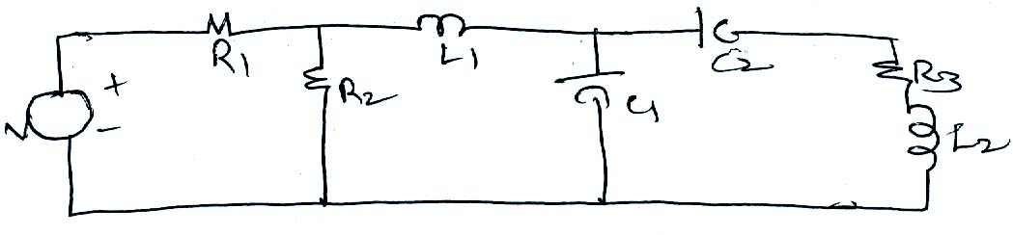
b) For the topological graph shown in the fig. obtain the fundamental tieset matrix choosing the tree containing elements 5 and 6 ?
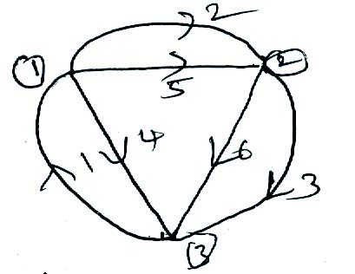
5. a) State and explain superposition theorem.

b) Use Thevenin’s theorem to find “I” in the circuit shown.
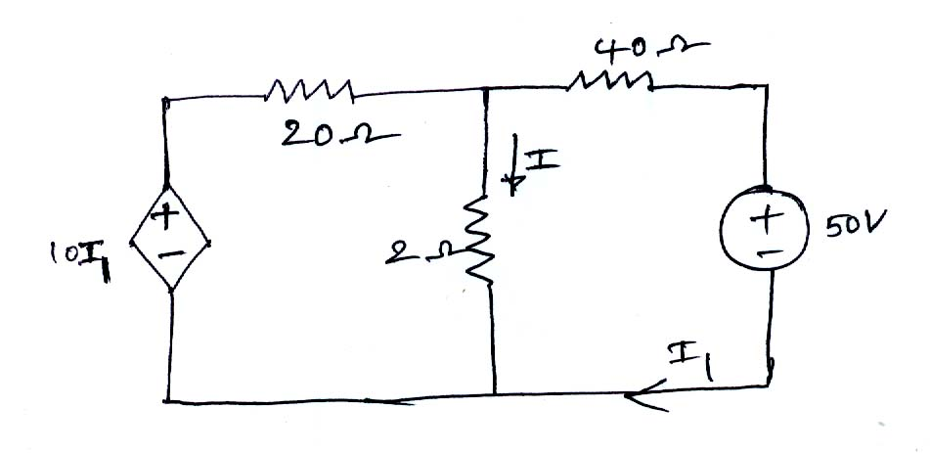
6. a) Express Z parameters in terms of y parameters.
b) Find Y Parameters of the two port network shown in figure.
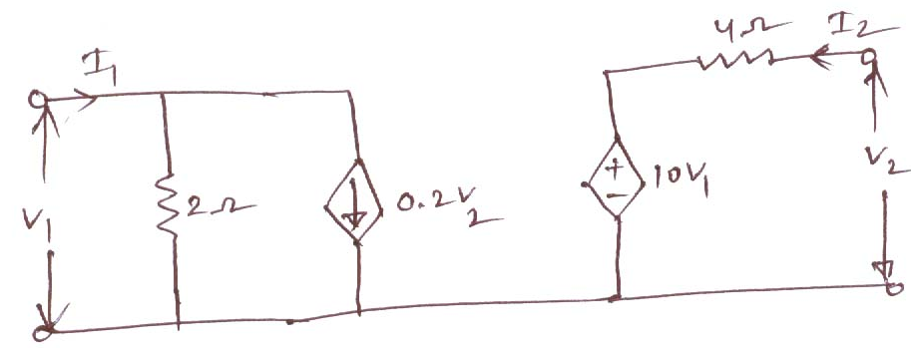
7. a) Derive the expression for current in series R-C circuit exited by DC source.
b) For the circuit shown in figure find the current equation for t >0 when the switch K is moved at t= 0 from position a to b. Assume that circuit is in steady state before t= 0 instant.
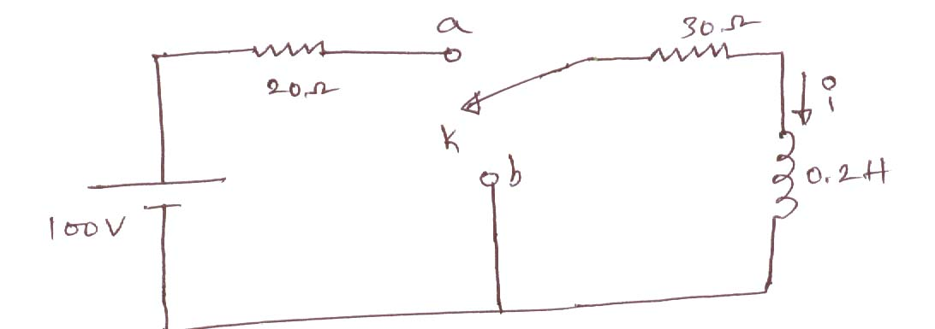
8. a) Derive necessary equations for two port networks connected in series.
b) Find the impedance parameters for the two port network shown below.
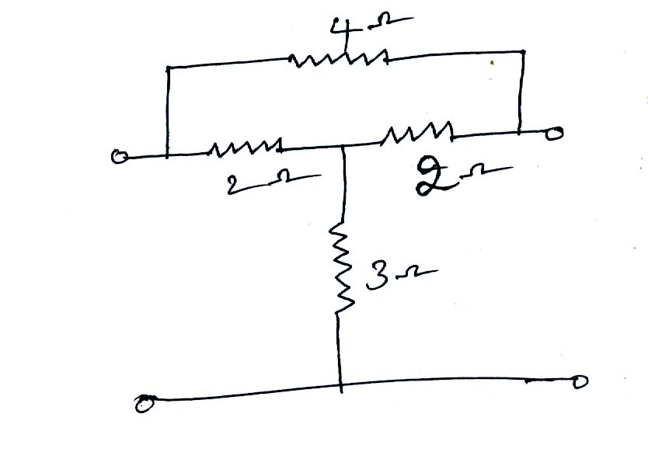
-- 00 -- 00 --

